Table of Contents

- Introdcution 4
- Definitions 4
- General Instructions 4
- ICV Calculation Formula 6
- ICV Template Instructions 7
i. ICV Summary 7
ii. General Questionnare 8
iii. Goods Manufacturing 9
iv. Third Party Cost 11
v. Investment 13
vi. Emiratization 14
vii. Expat Contribution 15
viii. Revenue 16
ix. Bonus 16
6. Final Checks by Supplier 17

- Introduction
In 2019 and 2020, various Government and semi Government companies (hereinafter referred to as “Participating Entities”) have joined hands to broaden the ICV certification process for Suppliers across various sectors in Abu Dhabi and the UAE. It is likely that more entities will join the ICV certification platform.
This document is intended to provide information and guidance to the Suppliers for undertaking the ICV certification process.
For ICV calculations, the following areas are considered:
- Goods Manufactured (only for Suppliers holding Industrial License)
- Third Party Spend (only for Suppliers holding non- Industrial License)
- Investment
- Emiratization
- Expatriate Contribution
- Bonus – i) Revenue from outside UAE, ii) Emirati Head count and iii) Investment Growth
The calculation details are explained in the subsequent pages. Government
- DEFINITIONS
- Participating Entities – All the entities who have implemented the In Country Value (ICV) program jointly are referred to as “Participating Entities”.
- Supplier(s) – The Company who wishes to acquire an ICV certificate.
- Empaneled Certifying Body – A Company who has been authorized by the Participating Entities for verification of Suppliers’ ICV certificate application and issues the ICV certificate
- Audited Financial Statements -Supplier's financial statement that has been prepared and audited by an independent certified public accountant in accordance with IFRS (International Financial Reporting Standards)
- ICV Certificate Template – means the template which the Supplier fills to calculate the ICV score as per predetermined formula.
- GENERAL INSTRUCTIONS
- Suppliers shall possess ICV certificate issued by an ICV Empaneled Certifying Body
- ICV certificate shall be obtained for each legal entity of the Supplier, which intends to be certified. Each license of a Company is considered as an independent legal entity even if the ownership is the same. However, if a Company has different branches in the same Emirate with identical activities and ownership listed on the licenses, then one combined ICV certificate will be issued for the Company in that Emirate.
- All figures entered in the ICV certificate template should tally with Supplier’s latest audited Financial Statements. The audited financial statements shall be as per the International Financial Reporting Standards (IFRS) and shall not be older than 2 years from the certification year i.e. for ICV certification in 2020, the audited financial statements to be considered shall not be older than 2018. For newly established Companies (less than 10 months old), who do not have audited financial statements, the Management Accounts for a period of up to 9 months can be used for ICV calculations. Any management accounts greater than 9 months will be required to be audited.
- The ICV certificate shall be valid for a period of 14 months from the date of issuance of Audited Financial Statements. Supplier can get recertified during the validity of the ICV certificate if he chooses to, using the same audited financial statements, but the validity of 14 months from the first issue will remain.
- Upon appointing an Empaneled Certifying Body, Supplier shall not change the Empaneled Certifying Body for that year’s ICV certificate without proper justifications.
- The figures reported in the ICV Certificate Template should relate to the figures in Supplier’s Audited Financial Statements or from the supporting documents used to generate the Audited Financial Statements. The different scenarios with respect to the consideration of Audited Financial Statements are as per the flow chart (Annexure-1) attached to these guidelines.
- Supplier’s submission shall consider all Supplier’s costs incurred and revenue earned during the financial year.
- The cost figures shall be in AED in the ICV Certificate Template unless specified otherwise. For currency conversions, the following shall be considered:
- 1 USD = 3.6725 AED
- Other currency conversion shall be done based on the prevailing rate on the Purchase Order for goods / services.
- In case the supplier is unable to provide the consumption details (listing by vendor and by invoice), purchases made during the year can be considered. In such a case, the differential of opening and closing stock should be adjusted as “others” to tie it back to consumption figure in the books of accounts. The “others” shall then be split into the same ratio of ‘total inside UAE costs’ and ‘total outside UAE costs’.
- Assumptions and calculation methodologies utilized in preparing the ICV Certificate. Template shall be consistent with these guidelines.
- Supplier shall have all documentation supporting the reported cost figures. The numbers will need to stand up to scrutiny by the Empaneled Certification Body. The designated personnel representing the Participating Entities have the right to conduct a quality review of each of the Empaneled Certification Bodies’ ICV engagements and review reports prepared by them. Suppliers and Empaneled Certification Bodies shall share the required information with designated personnel whenever required.
- Any gross negligence or willful default by Suppliers in their submissions will result in appropriate punitive measures including being banned from participating in business with Participating Entities.
- Supplier shall strictly follow the ICV Certificate Template to generate their ICV score / certificate. Supplier shall fill out the figures and other details.
- For the purpose of Supplier’s ICV calculations, the following shall be considered for different types of Companies:
Type of Company | Consideration for ICV
LLC in mainland UAE  (Limited Liability Company) | Within UAE
Free Zone Companies | Goods Manufacturer - Within UAE  Service Providers - All attributes except Investment will be considered within UAE
Offshore Companies | Outside UAE
Representative Office | Based on parent company
Branch Office in mainland UAE | Within UAE

- Suppliers are encouraged to amend their existing trial balance codes appropriately to separately capture specific costs required by ICV. This ensures that certification is smooth and cost effective for future years. For example, Suppliers could have a separate code for Emirati payroll costs, training costs, manufacturing costs – overseas, etc.
- Supplier shall register in the www.aejobs.ae portal which is a platform for Emirati job seekers and companies offering jobs. Suppliers are provided a period of 14 months from ICV certification to register in the portal. Suppliers who fail to register within 14 months will not receive the credit for Emiratization and Expat contribution in the next renewal of their ICV certificate.

- ICV CALCULATION FORMULA
- Goods Manufacturer – Supplier who manufactures and supplies a finished product to an external customer. A Supplier holding the Industrial License in Abu Dhabi (or equivalent license in other Emirates) shall be considered as Goods Manufacturer. For a Supplier who is a Goods Manufacturer, the following attributes will be considered:
- Goods Manufacture Cost
- Investment in UAE
- Emiratization
- Expatriate contribution
- Bonus – Revenue from outside UAE, Emirati Head counts & Investment Growth
- Service Provider – Any Supplier who is not a Goods Manufacturer is considered as “Service Provider”. A Supplier who has a license other than “Industrial License” shall be considered as Service Provider. For a Supplier who is a Service Provider the following attributes will be considered:
- Third party spend cost
- Investment in UAE
- Emiratization
- Expatriate contribution
- Bonus - Revenue from outside UAE, Emirati Head counts & Investment Growth
- A Supplier who is an Agent / Trader will be considered as “Service Provider”. However, an Agent trading exclusively only one principal Goods Manufacturer in UAE shall be considered as Goods Manufacturer.
- The formula for calculation of ICV score along with the weightage for each of the attributes is detailed below:
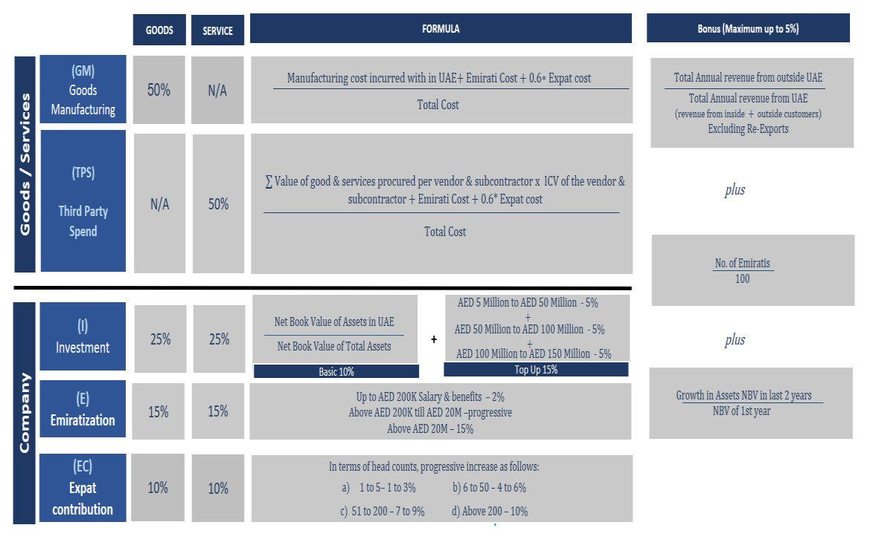

- The ICV Certificate Template consists of a Microsoft Excel file with tabs dedicated to each of these attributes, wherein the Supplier has to fill the figures from the Audited Financial Statements as explained in subsequent pages of these guidelines.
- Throughout these Supplier guidelines, the page number headings correspond to the separate tabs which have been incorporated into the “ICV Certificate Template” that is used to calculate the ICV% of Supplier.
- ICV Template Instructions
- ICV summary
Page – 1 ICV Summary
Applicability – Applicable for all Suppliers

The Supplier is required to fill the following:
- Section A – Company General Information
An extract of the Company General Information section of the ICV Certificate Template is shown below:
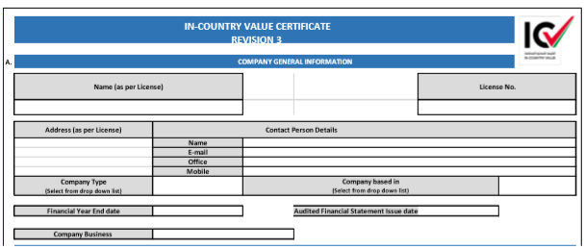
Supplier is required to add the following details in the template:
- Name as per License – name of the Supplier as mentioned in the license
- License Number
- Address as per License
- Contact Person Details:
- Name
- E-mail
- Office Tel number
- Mobile number
- Company Type – choose the appropriate type from the dropdown list:
- Small Medium Enterprise (SME) in UAE
- Non-SME in UAE
- International Company

For selection of of SME/Non SME, please be guided by as per SME definition in website of National Program for Small and Medium Enterprises and Projects (https://www.uaesme.ae/About/SMEDefinition)

- Company based in - choose the appropriate type from the drop down list:
- Within UAE
- Outside UAE
Note - Goods Manufacturers in Free Zone should choose “Within UAE” and Service Providers in Free Zone should choose “Outside UAE”
- Financial Year End Date – Supplier shall fill the end date of the Financial year based on which the ICV certification is being applied for. An ICV certificate cannot be issued 2 years after this date. The date shall be entered in (mm/dd/yyyy) format.
- Audited Financial Statements Issue date – Supplier to enter the date of issuance of the Audited Financial Statements. The ICV certificate will be valid for 14 months from this date. The date shall be entered in (mm/dd/yyyy) format.
- Company Business - choose the appropriate type from the drop down list:
- Goods Manufacturer
- Service Provider
(Refer to section 3. a and 3.b above for guidance)
- Section B – In-Country Value Details
This Section is protected, and Supplier shall not enter any information in this Section.
The results are auto calculated based on the figures entered by the Supplier in subsequent tabs (Page 2 through Page 7)
The validity date of the ICV score is auto calculated as per Section 2.d) of these guidelines.
This page shall bear the signature of Suppliers’ Power of Attorney or any senior / authorized signatory Company stamp and date; and Certifying Body representative’s signature, Designation, Company Stamp and date.
This Page duly signed by the Supplier’s POA or authorized executive and Empanelled Certifying Body representative shall be considered as Supplier’s Company ICV Certificate.
- General Questionnaire
Page – 1 A General Questionnaire
Applicability – Applicable for all Suppliers

All Suppliers shall fill in the general questionnaire based on the reported financial year.
The details provided in the general questionnaire are only for Participating Entities information and will not affect the ICV score calculations.

- Goods Manufacturing
Page – 2 Goods Manufacturing
Applicability – Applicable for all Suppliers

Supplier shall fill the following:
- Goods Description
Supplier has to list all Goods manufactured by Supplier in the latest audited financial year, in broad categories. If there are multiple goods falling under same or similar category, these can be combined together as one-line item in the template.
Note - Training cost for Employees shall not be included in the Third Party Spend (shall be included in Emiratization or Expat tabs)
- Total Cost
Supplier shall provide the breakdown of total cost for each good listed in the table. The breakdown shall be as follows:
- Level – 1
Total cost will be split into:
- Within UAE cost – All costs incurred within UAE
- Outside UAE cost – All costs incurred outside UAE

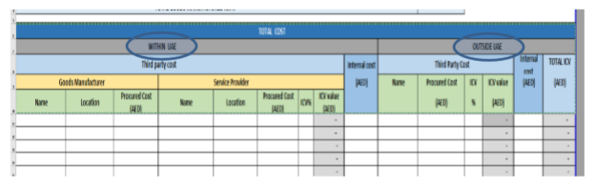
- Level – 2
“Within UAE” & “Outside UAE” cost shall be further split into:
- Third Party Cost – All cost paid to third party companies
- Internal Cost – Only Depreciation / Amortization cost of Assets to be considered
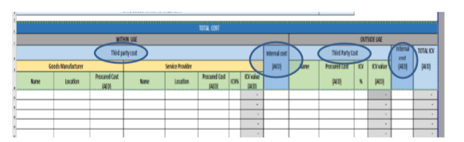
- Level – 3
Third party cost under “Within UAE” – This shall be further split into:
- Goods Manufacturer – Company holding industrial license
Supplier shall enter the name of the Manufacturer, Location of the Manufacturer (one of the seven Emirates in UAE) and the cost of purchases from the Manufacturer.
The cost of purchases from UAE Manufacturer will be considered as 100% incurred ‘within UAE’.
- Service Provider – Company holding a license other than Industrial license
Supplier to enter the name of the Agent/Service Provider, Location of the Service Provider (one of the seven Emirates in UAE), cost of purchases and ICV% of the Service Provider.
In case of “Within UAE” cost will be calculated by multiplying cost of purchases from the Agent / Service Provider with ‘50%’ or ‘ICV% of the Agent/Service Provider’, whichever is higher.
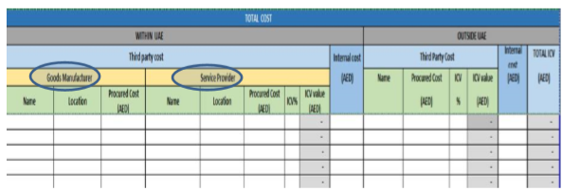
For Third party Service Providers for Utility and other Services in UAE, the following shall be considered:
Services | ICV%
Water / Electricity | 80%
Fuel | ICV of the provider
Rent paid for property / land from individuals or companies | 80%
Telecom Providers | As per the ICV of the provider
UAE Government charges - Directly paid to Government or through Government licensed entities | 100%
Payment to Governmental Free Zone authorities in UAE | 100%
ADNOC Group Companies except ADNOC Distribution, ADNOC Drilling, ADNOC Logistics & Services and Borouge | 80%
ADNOC Distribution, ADNOC Drilling, ADNOC Logistics & Services and Borouge | ICV of the company

Third party under “Outside UAE”-
In this Section, Supplier shall provide the name of the Manufacturer/ Agent/ Service Provider, cost of purchases and ICV% of the Manufacturer/ Agent/Service Provider.
- The following shall not be included as part of the costs:
- Management Fee
- Sponsorship Fee
- Governmental Fines / Penalties
- Charity amount / expense for Corporate Social Responsibility
- While considering the vendors from Free Zone, the following shall be noted:
- “Goods Manufacturers” based in Free Zone will be considered as “Within UAE”
- “Service Providers” based in Free Zone will be considered as “Outside UAE”

- ICV Calculation
The ICV is calculated as follows:
(Total ICV value) + Emirati cost (Page-5) + 0.6 x Expat cost (Page-6)
-------------------------------------------------------------------------------------------- x 0.5
(Total Cost) #

Note – (#) – Total Cost includes all cost except the items mentioned in (iii) above and shall be calculated from total cost in Page 2 (Goods Manufacturing), Page 5 (Emiratization) and Page 6 (Expat contribution)
- Third Party Cost
Page – 3 Third Party Cost
Applicability – Applicable for all Suppliers

An extract of the ICV Certificate Template is shown below:
THIRD PARTY SPEND
TOTAL THIRD PARTY ICV%
Goods / Services Description | Vendor Name | Cost of Procurement (AED) | Location | Vendor ICV% | In Country Procurement  Value (AED)
 |  |  |  |  | -

- Goods / Services Description
Supplier has to list out all the Goods/Services procured by him in the previous financial year in broad categories. If there are multiple goods falling under same or similar category, it can be combined together as one-line item in the template. For example – different specifications of valves procured could be combined as one-line item titled “Valves”.
Note - Training cost for Employees shall not be included in the Third Party Spend (same to be included in Emiratization or Expat tabs)
- Supplier Name
Supplier shall indicate the “Vendor name” who has supplied the goods
- Cost of Goods Purchased
Supplier shall provide the Cost of Goods (Cost of Sales) purchased from the Vendor.
- Vendor ICV %
Supplier shall indicate the ICV% of the Vendors. This should be backed up with ICV certificates of Vendors issued by one of the Empaneled Certifying bodies. For the purpose of ICV calculation only, a vendor who is based in UAE mainland will be automatically granted 10% ICV score. For all other vendors, the ICV score shall be considered as zero (0) if they do not have valid ICV certificate.
All operating costs like Water / Electricity, Fuel, Rentals of property/equipment, Telecom and Government charges shall be considered in the Third Party spend. Vendors from whom such services are procured will have their ICV’s as under:
Services | ICV%
Water / Electricity | 80%
Fuel | ICV of the provider
Rent paid for property / land from individuals or companies | 80%
Telecom Providers | As per the ICV of the provider
UAE Government charges - Directly paid to Government or through Government licensed entities | 100%
Payment to Governmental Free Zone authorities in UAE | 100%
ADNOC Group Companies except ADNOC Distribution, ADNOC Drilling, ADNOC Logistics & Services and Borouge | 80%
ADNOC Distribution, ADNOC Drilling, ADNOC Logistics & Services and Borouge | ICV of the company
- While considering the vendors from Free Zone, the following shall be noted:
- “Goods Manufacturers” based in Free Zone will be considered as “Within UAE”
- “Service Providers” based in Free Zone will be considered as “Outside UAE”
- The following shall not be included as part of the costs:
- Management Fee
- Sponsorship Fee
- Governmental Fines / Penalties
- Charity amount / expense for Corporate Social Responsibility
- Depreciation / Amortization cost of Assets can be considered in the table with 100% ICV
- ICV Calculation
The ICV is calculated as:
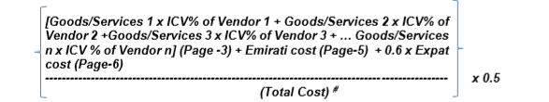

Note – (#) – Total Costs include all cost excluding the items mentioned in (vii) above and calculated from total costs in Page 3 (Third Party Spend), Page 5 (Emiratization) and Page 6 (Expat contribution)
Investment
Page – 4 Investment
Applicability – Applicable for all Suppliers

An extract of the ICV Certificate Template is shown below:
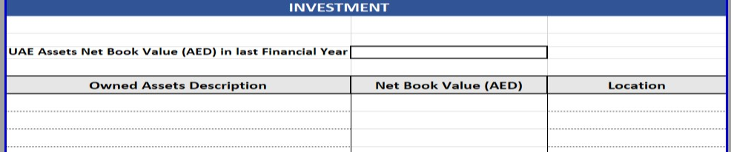
- Supplier shall fill the UAE Assets Net Book Value (AED) in the previous Financial Year. This figure is used to calculate the investment growth bonus
- Owned Assets Depreciation
Fixed Assets owned by Supplier as per the Audited Financial Statements along with the location (i.e., Inside UAE or Outside UAE) shall be reflected in Page – 4.
Fixed Assets will include the following categories:
  - Property, Plant and Equipment (including any ERP costs)
  - For IT companies, software development costs will also be included
  - Capital Work in Progress
  - Investment Property
All other intangibles shall be excluded from investments
The investments outside the UAE shall also be reflected appropriately in the ICV Certificate Template.
In case Supplier has revalued their Property, Plant and Equipment, the value of the Property, Plant and Equipment shall be reduced by the extent of the balance in the revaluation reserve at the Balance Sheet date.
- Net Book Value
For all the assets listed, Supplier shall provide the Net Book Value as per the Audited Financial Statements
- Location
Supplier shall select one of the locations from the value list – “Inside UAE” or “Outside UAE”
- ICV Calculation
The ICV is calculated as follows:
Net Book Value of Assets in UAE
------------------------------------------------- x 0.1 (weightage 10%)
Net Book Value of Total Assets
+
15% on progressive basis from Asset NBV of AED 5 Million to AED 150 Million

- Emiratization
Page – 5 Emiratization
Applicability – Applicable for all Suppliers

- An extract of the ICV certificate template is shown below:

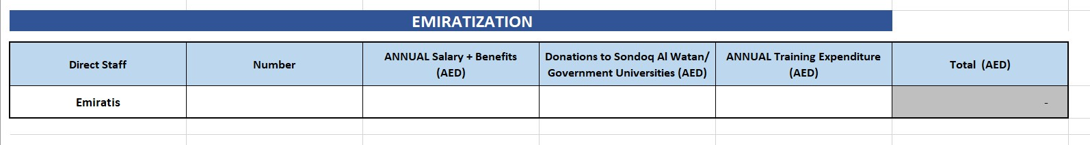
- Supplier shall fill the following for direct staff Emiratis, who are on Supplier’s payroll:
- Number - Average Number of Emirati employees in Supplier’s payroll (Wage Protection System – “WPS” where applicable) in the year as per Ministry of Human Resources and Emiratization (MOHRE) statistical report.
- Annual Salary + Benefits (AED) - Salary + Benefits as per the Financial Statements (includes all benefits paid to direct Emirati staff including salaries, allowances and other benefits). Only salary and benefits of those Emiratis who are included in the Wage Protection System (WPS) shall be considered in ICV.
- Donations to Sondoq Al Watan / Government Universities (AED) - Donations made to Sondoq Al Watan or any of the universities listed in the Agreed Upon Procedures (AUP) shall be considered as part of Emiratization.
- Annual Training Expenditure (AED) - Training Expenditure (includes spend by Supplier on external training provided to direct Emirati staff. Cost incurred on internal training courses shall not be included). Only expenditure included in Audited Financial Statements shall be considered for ICV.
- Any sponsorship / management fees paid to Emiratis outside of WPS shall not be considered.
- Salary of Emirati owners of the Company (as per ownership in the License) who are part of the WPS can be included, however it shall be capped to a total of AED 120,000/- monthly per owner. Bonuses or other benefits shall be excluded from the calculations.
- Free Zone companies who are not registered in the WPS system, shall provide documentary evidence from Free Zone authority on the details of employees, in order to consider the number and salary / benefits in the calculations.
- Shared employee costs shall be considered as per the financial statements. Where an Emirati's cost is being charged off by a group entity, consider these costs as part of the overall manpower cost. However, this Emirati shall not be considered for calculation of total number of manpower (therefore, it shall not affect the Emirati bonus element of the ICV).

- ICV Calculation:
With regards to Annual Salary, benefits & training for total Emirati employees, the ICV is calculated as follows:
Up to 200K AED – 2%
and
Progressive up to 20 M AED Annual Salary – 15%

- Expat Contribution
Page – 6 Expat Contribution
Applicability – Applicable for all Suppliers

- An extract of the ICV Certificate Template is shown below:

Direct Staff | Number | ANNUAL Salary + Benefits  (AED) | ANNUAL Training Expenditure  (AED) | Total (AED)
Expats |  |  |  | -

- Supplier shall fill the following for direct staff Expats, who are on Supplier’s payroll:
- Average Number of Expatriate employees in Supplier’s payroll (Wage Protection System - WPS where applicable) in UAE in the year as per Ministry of Human Resources and Emiratization (MOHRE) statistical report
- Salary + Benefits (includes all benefits paid to direct Expatriate staff including salaries, allowances and other benefits) included in Audited Financial Statements. Only salary and benefits of those Expats who are included in the Wage Protection System (WPS) shall be considered in the ICV.
- Training Expenditure (includes spend by Supplier on external training provided to direct Expatriate staff. Cost incurred on internal training courses shall not be included). Only expenditure included in Audited Financial Statements shall be considered for ICV.
- Free Zone companies who are not registered in the WPS system, shall provide documentary evidence from Free Zone authority on the details of employees, in order to consider the number and salary / benefits in the calculations.
- ICV Calculation
The ICV for expat contribution is calculated as follows:
Number of Expats | ICV%
1 to 5 | 1 to 3%
6 to 50 | 4 to 6%
51 to 200 | 7 to 9%
Above 200 | 10%

- Revenue
Page – 6 Expat Contribution
Applicability – Applicable for all Suppliers

- An extract of the ICV Certificate Template is shown below:
S.No. | Revenue in last financial year | AED
1 | From UAE Customers
2 | From Outside UAE Customers
a. | ✓ Re-Exports (export of goods without value addition)
b. | ✓ Exports excluding re-exports.
Total |  | -

- Supplier needs to indicate the Revenue “from UAE Customers” and “from Outside UAE Customers” in AED.
- Revenue from Free Zone companies will be considered as “from UAE Customers”.
- With regards to “from Outside UAE Customers”, Supplier shall provider the breakdown as follows:
- Re-Exports – Revenue earned from re-exports i.e., when the imported goods are sold to outside UAE customers without any “value addition”
- Exports excluding Re-exports – Revenue earned from outside customers after value addition within UAE by Supplier.

- Bonus
Bonus (maximum up to 5%)
Applicability – Applicable for all Suppliers

Supplier’s eligibility bonus shall be calculated as follows:
- Revenue from Outside UAE
Only Supplier’s legal entities who are based in UAE are eligible for this bonus:
Total Annual Revenue from outside UAE customers excluding Re-exports
-------------------------------------------------------------------------------------------------- x 5%
Total Annual revenue (from inside + outside UAE)

Note – The revenue earned from outside UAE – without any value addition; shall not be considered in bonus. Trading and commission earnings by agencies shall not be considered as revenue from outside UAE.

The revenue from outside UAE shall be considered only when the payment is received by the Supplier from outside UAE.
- Emirati Head count
Number of Emiratis who are enrolled in the WPS will be considered for bonus. It is calculated as follows:
Number of Emiratis /100 x 5%
- Investment Growth
Growth % in Net Book value of Assets in last two Financial Years (current Audited Financial Statements versus Audited Financial Statements of previous year) is included in bonus. The formula is as under:
(Net Book value of UAE Assets in current FS - Net Book value of UAE Assets in audited Financial Statements of previous year)
---------------------------------------------------------------------- ------------------------- x 5%
Net Book value of UAE Assets in audited Financial Statements of previous year

The total of all components - (a) Revenue from outside UAE Bonus, (b) Emirati Headcount and (c) Investment Growth shall not exceed 5%.

- Final Check by Supplier
- After filling in the templates, Supplier shall verify all details and ensure alignment with Supplier’s Audited Financial Statements.
It is recommended that Suppliers engage their Finance and other concerned staff to verify the figures.
In case of any queries, Supplier can contact ALDAR at icv@aldar.com
- The certificate when:
- duly signed and stamped by the company’s Power of Attorney or senior / authorized signatory
and
- Duly verified and endorsed by one of the ICV Empaneled Certifying Bodies. becomes the ICV certificate valid till the date mentioned in the ICV certificate.

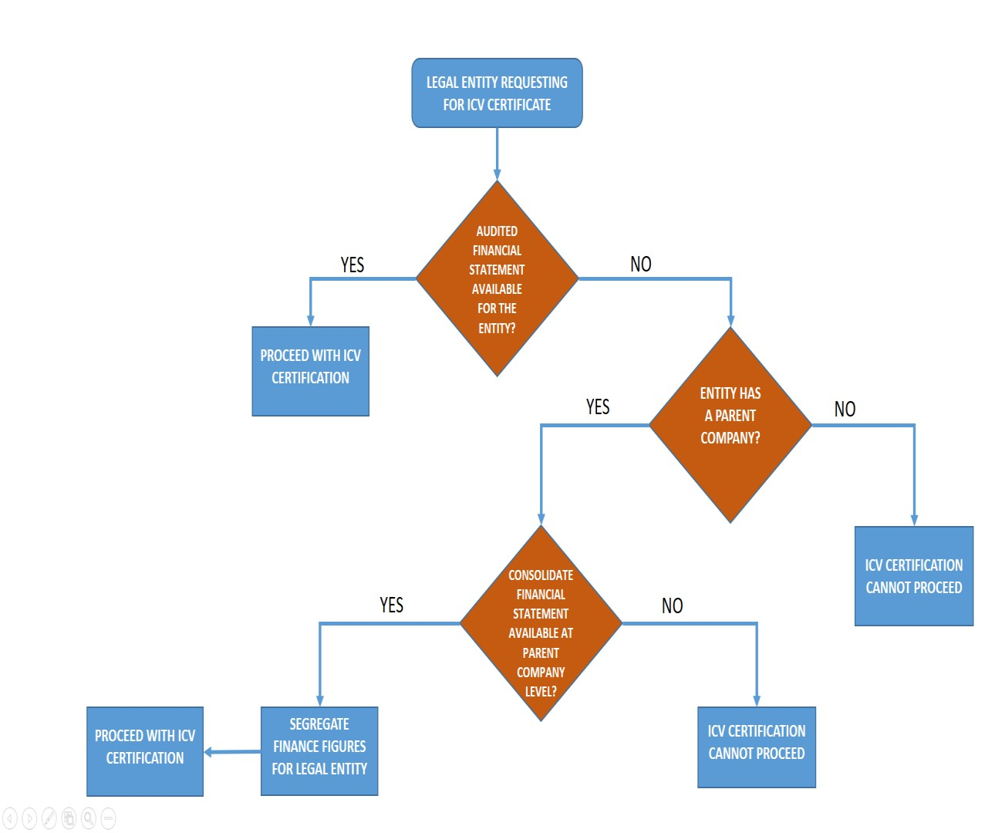
Annexure -1

